SIMATS ENGINEERING (SAVEETHA SCHOOL OF ENGINEERING)

Department of Computer Science and Engineering

ASSESSMENT TOOL 1 – ANALYTICAL PROBLEM SOLVING

Course Code: | CSA0618 | Course Title: | Design and Analysis of Algorithms
CO Assessed: | CO2 – Manipulation (BL1, BL2, BL3) | Assessment: | Assessment Tool 1 – Analytical Problem Solving
Weightage: | 40% of CIA | Total Marks: | 100
CO2 Statement: | Apply Brute Force technique to solve sorting, searching, Closest-Pair and Convex-Hull problems (BL1, BL2, BL3)
Student Name: | DHANUSH KUMAR R | Reg. No.: | 192411215
Section / Batch: | BS CSE | Date: | 24.07.2026
Instructions to Students
- Answer the following question. Total Marks: 100.
- Analyze each problem carefully before applying the appropriate Brute Force technique.
- Clearly show all intermediate steps, comparisons, iterations, and logical reasoning used in solving the problems.
- Apply suitable algorithms for sorting, searching, Closest-Pair, and Convex-Hull problems wherever required.
- Justify the correctness and efficiency of the proposed solution using appropriate complexity analysis.
- Use diagrams, tables, or stepwise illustrations wherever necessary for better explanation.
- Maintain neat presentation, proper algorithmic notation, and structured analytical reasoning throughout the answers.

Question Type | Focus Area | Questions
Application-Based Questions | Apply Brute Force techniques for sorting, searching, Closest-Pair and Convex-Hull problem analysis | Q1

SECTION A – APPLICATION BASED QUESTIONS

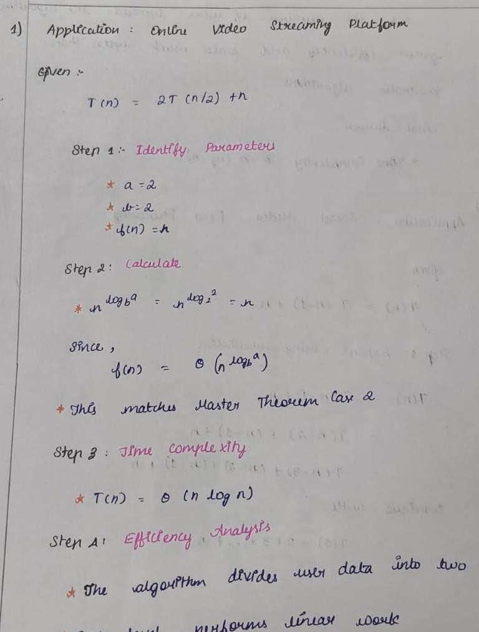

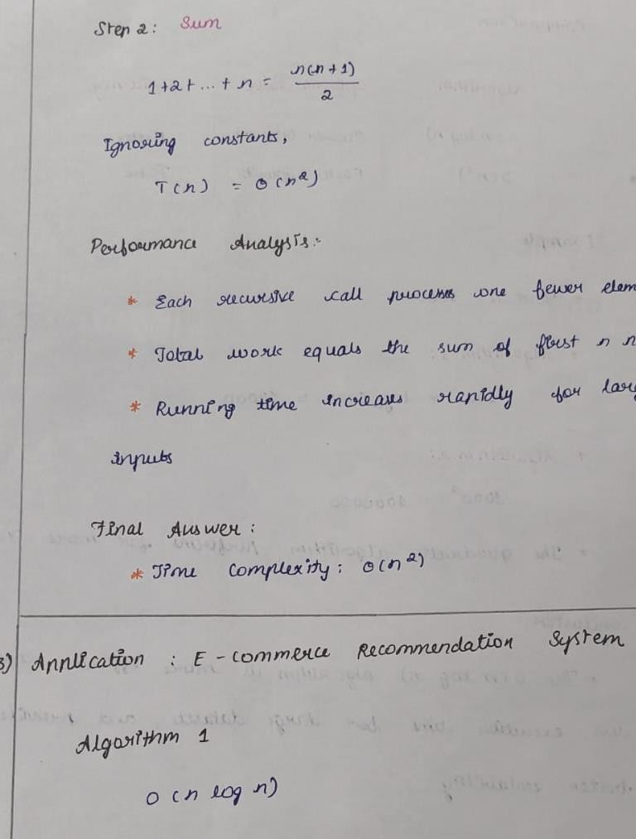

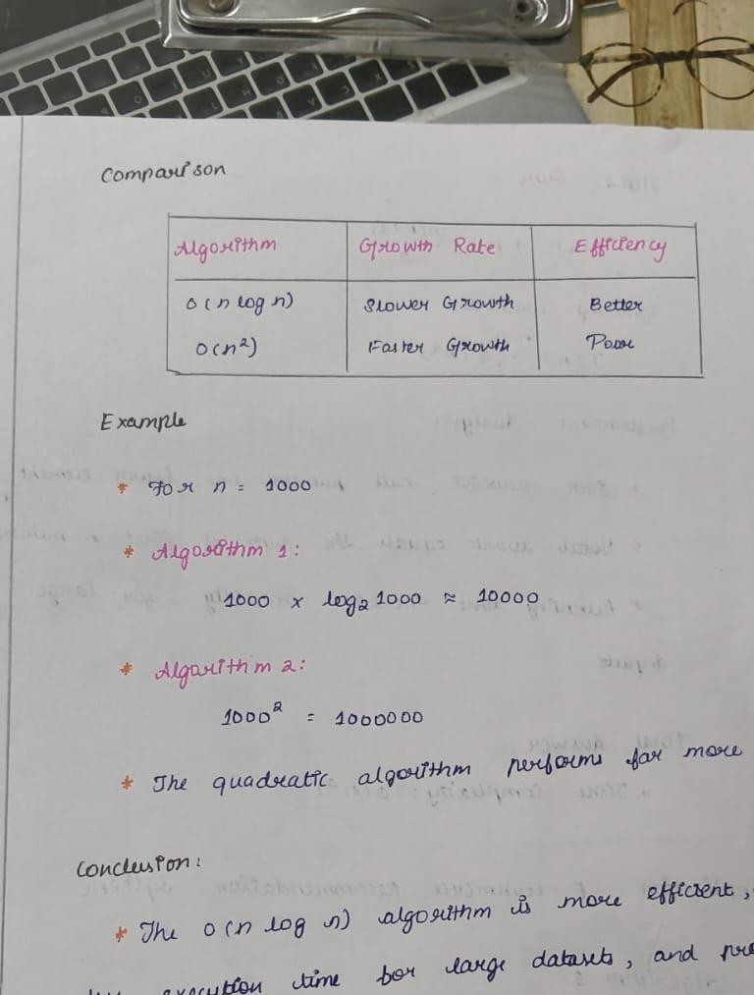

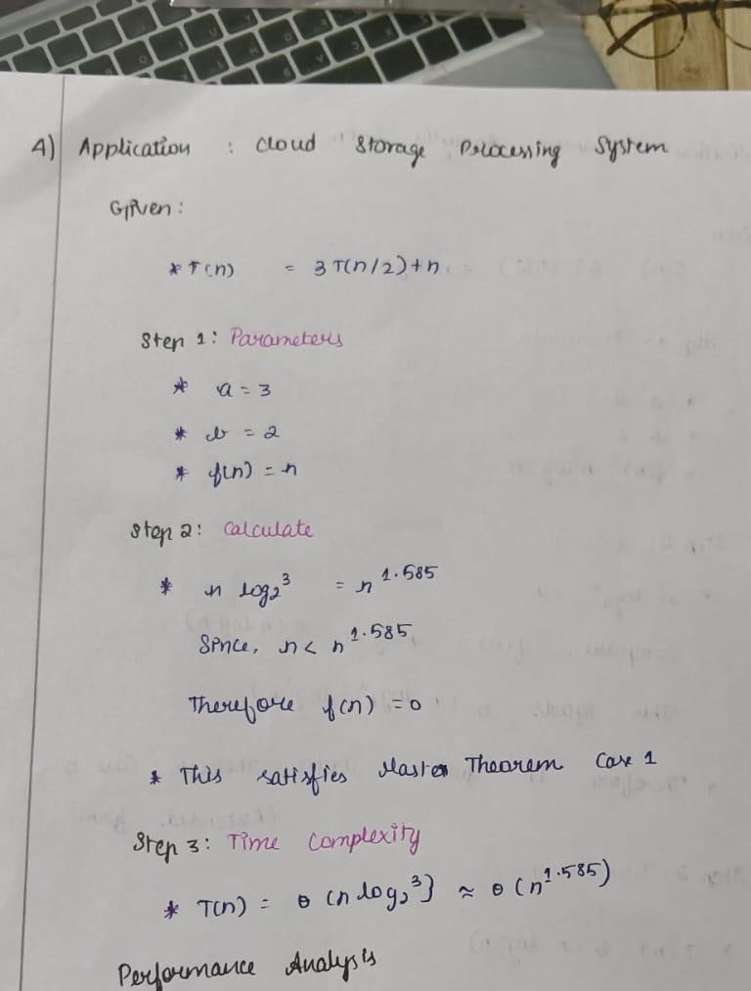

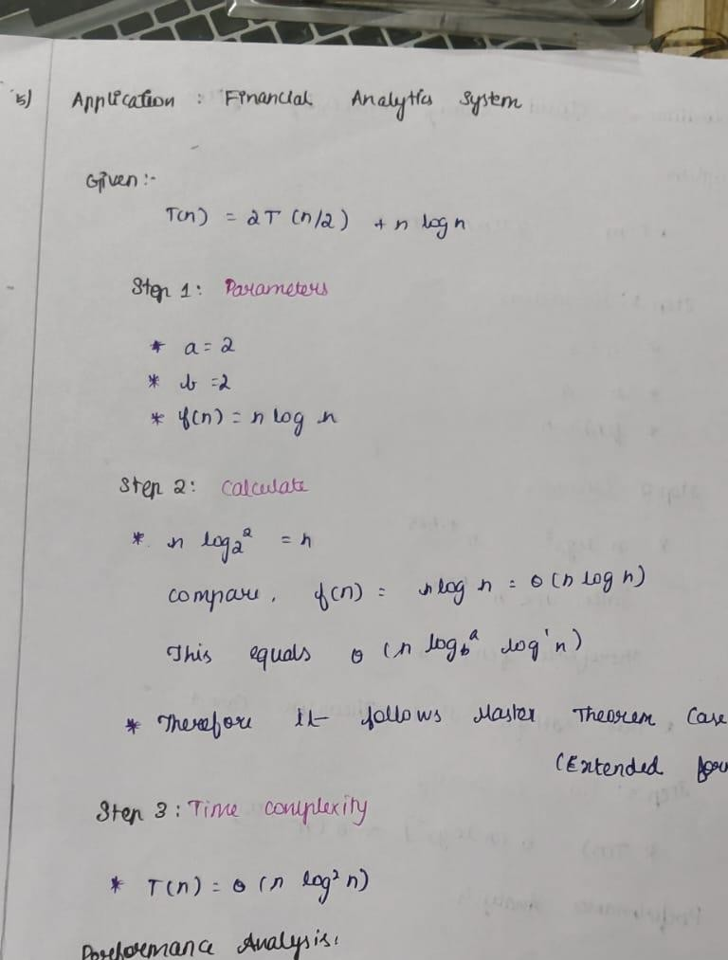

Code of Conduct
I Dhanush Kumar R (Name / Reg No) certify that this submission is my original work and that I have adhered to the guidelines specified for this assessment. I understand that any violation of academic integrity rules will result in disciplinary action.
Signature of the Student: Dhanush Kumar R

RUBRICS FOR CALCULATION
Criteria | Wt. | Level 4 – Exemplary | Level 3 – Proficient | Level 2 – Developing | Level 1 – Beginning
Understanding of Problem Context | 20% | Clearly understands the problem and accurately identifies all requirements | Good understanding with minor gaps | Basic understanding; some requirements unclear | Poor understanding or misinterpretation of the problem
Application of Concepts | 30% | Accurately applies appropriate concepts to solve complex problems | Applies relevant concepts correctly with minor errors | Applies basic concepts with limited accuracy | Fails to apply appropriate concepts
Problem-Solving Approach | 20% | Logical, well-structured, and efficient approach | Mostly logical approach with minor gaps | Basic approach with some inconsistencies | Illogical or unclear approach
Accuracy of Solution | 20% | Completely correct solution with proper justification | Mostly correct with minor errors | Partially correct solution | Incorrect or incomplete solution
Clarity | 10% | Clear, well-organized, and properly explained solution | Understandable with minor clarity issues | Limited clarity and explanation | Poorly presented and difficult to understand

Marks Evaluation:
Criteria | Wt. | Level 4 – Exemplary | Level 3 – Proficient | Level 2 – Developing | Level 1 – Beginning
Understanding of Problem Context | 20%
Application of Concepts | 30%
Problem-Solving Approach | 20%
Accuracy of Solution | 20%
Clarity | 10%
Total Marks (100):

Faculty In-charge | Course Coordinator | Head of Department
Name: | Name: | Name:
Signature: | Signature: | Signature:
Date: | Date: | Date:

